

NETFLIX DATA ANALYSIS PROJECT
(by Om Satyawan Pathak)

ABOUT AUTHOR:
Name: Om Satyawan Pathak
Contact Details:
Email - ID:
omsatyawanpathakwebdevelopment@gmail.com
WhatsApp:
+91 9426048518

Photograph:
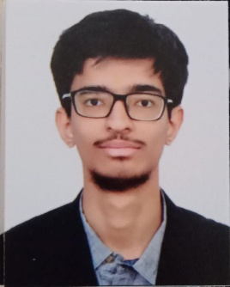

Signature:
